Chapter 1. Overview RAMP-TRIM

and

Organization Work Units

Table of Contents

1.1 Introduction 3
1.1.1 Records Lifecycle 3
1.1.2 Training Component - Courses Available 3
1.1.3 RAMP Design and Future Modules 3
1.1.4 Originator of Records - Organization Tree 4
1.1.5 Management Briefing Questions 4
1.1.6 How to Locate an Organization Work Unit 4
1.2 Overview Screens 5
1.2.1 Login To RAMP-TRIM 5
1.2.2 Locate an Organization Work Unit 6
1.2.3 Saved Searches 11
1.2.4 Help File 12
1.2.5 Record View and Record List Pane 12
1.3 Overview Exercise 14
1.3.1 Organization Tree - Fill in Division and Section. 14
1.3.2 Display a Work Unit. 14
1.4 Key Learning Points & Charts Used in Presentation. 15
1.4.1 Record Lifecycle. 15
1.4.2 RAMP-TRIM Design. 15
1.5 Self-Test. 16
1.5.1 Questions for RAMP-TRIM Introduction and Overview. 16
1.5.2 Questions and Answers. 17

List of Figures

Figure 1. Login Screen 5
Figure 2. Re-login with the Folder Icon 6
Figure 3. Menu selections Search and Find 6
Figure 4. Basic Search Panel 7
Figure 5. Dropdown 8
Figure 6. Kwikselect Option 8
Figure 7. Hierarchical List of Search Fields 9
Figure 8. Searching with Partial Words 10
Figure 9. List of all Records starring with "Rur" 10
Figure 10. Top of the Locations Table 10
Figure 11. Typical Hierarchical Locations List after being opened using the + characters 11
Figure 12. Locations Search Panel 11
Figure 13. Partial Saved Search Screen 12
Figure 14. Help Screen 12
Figure 15. Record View Pane & Record List Pane 13

1.1 Introduction

1.1.1 Records Lifecycle

Narrative from Presentation:

- Request, Receive, Create
- Log (Register), Assign, Route, Track
- Cross Reference, File, Retrieve for Reuse
- Pack, Transfer off Site, Retrieve for Reuse
- Appraise, Identify Long term retention
See Records Lifecycle chart on page 1-? [to be redone

Parking Lot Issues Related to RAMP-TRIM and Record Life Cycle

- Disposal: Alternate Media/Destruction
- See Intro PowerPoint Presentation list and
- Participants concerns – “Parking Lot”

1.1.2 Training Component - Courses Available
Fundamentals

- Overview - Organization Tree & Work Unit
- Record Series Inventory

Intermediate

- File Folder Listing
- Shipment/Transfer - Box/Container

For additional information See RAMP Training Modules chart Annex E

1.1.3 RAMP Design and Future Modules

Narrative from Presentation:

See RAMP Design chart on page 1-14.
See Table of contents guide to RAMP-TRIM

1.1.4 Originator of Records - Organization Tree
- Directory of Work Units
- Originator versus Owner of Records
- Owner, Home and Current Location
- UNICEF ownership of Records
- Preliminary Appraisal by Work Units
- Final Appraisal by RAM & UN Archives [Appraisal Grid
- See also Annex G for Policy and Procedure guidelines list

See Organization Tree Exercise 1.3 on pages 1-14 and 1-15

1.1.5 Management Briefing Questions

Narrative from Management Briefing for Divisions arranged with RAM Unit.

See Management Briefings on Annex F.

1.1.6 How to Locate an Organization Work Unit

There are a number of ways to locate an Organization Work Unit after logging on to RAMP TRIM.

Use the Organization Tree [Hierarchical]

Search without specifying a work unit. The Hierarchical list will be displayed. Navigate through various levels of the displayed organizational chart for progressively more specific information on City, Division, Section and Unit.

Search for One work unit

Search for the unique Division, Section, or Work Unit by the first few letters of the work unit name

Search for the parent Unit

Using either of the methods above locate the “parent” work unit and drill down to the work unit required. A “parent” work unit is the supervising authority.

Locations

In RAMP-TRIM you will be introduced to the concept of 3 types of Locations:

  - Owner
  - Home
  - Current

Demonstration:
The following sections give a detailed screen-by-screen presentation.

Contacts:
In addition to identifying work unit locations for a record, it may be useful to identify one or more staff members as the Contact for a specific record or file. This will be demonstrated in the Series and folder RAMP-TRIM training modules

Unit, Position, Staff
In some circumstances you may also be able to search by the Position [post title] or Staff [individual name]. This will be further demonstrated in the Folders RAMP-TRIM Training module.

1.2 Overview Screens

1.2.1 Login To RAMP-TRIM

Begin by logging onto the RAMP-TRIM application using these procedures.

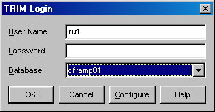
Figure 1. Login Screen

- Double Click on the RAMP-TRIM icon on the workstation menu bar, which will open the application.
- At “TRIM Login” (Figure 1, Login Screen) prompt you are ask to enter your User Name and Password, and select a Database. Type your network user name then TAB to the Password field and type your password.
- The database default setting is correct. You need not change the database. Later, you may need to login to another database, choose it from the Database drop-down list.
- Choose OK.
- If login fails, press the Folder Button (Figure 2. Re-login with the Folder Icon) or select Login from the File Menu and the Login Box will reappear.

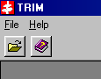
Figure 2. Re-login with the Folder Icon

þ Tip Passwords are case sensitive. Check your CAPS Lock keys if you fail to log in yet believe your user name and password is correct.

1.2.2 Locate an Organization Work Unit

You can conduct different searches on the RAMP-TRIM data. The kind of search conducted will depend upon what you know about the record. For example, you might search for words occurring in the title on notes field, or you might only know that the record belongs to a unit, department or individual in which case you will search for records owned by them.

To illustrate searching for records owned by a business unit do the following.

- Navigate the menu selection Search and Find.

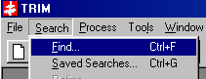
Figure 3. Menu selections Search and Find

- This selection will launch the basic search screen. Observe the screen structure. The field titled Search By identifies the field that will be searched. The field below, titled Title Word in this example [this title changes when the Search By value is changed], shows the value or text that will be located. We will return to these values in step 3, but first examine the menu displayed on the screen right. It contains settings for the Record Type, Advanced Searching, Sorting & Filtering and the Do Search button.

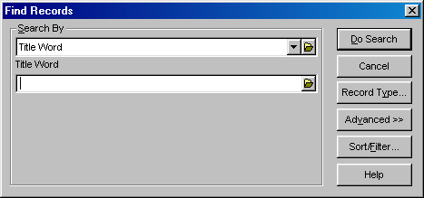
Figure 4. Basic Search Panel

Record Type A number of different Record Types are available and you may search all record types or narrow your search to a specific record type. Always check the Record Type selection and assure that you are searching for the proper record type. Consider narrowing the search to fewer or a single Record Type. This search strategy may reduce the total volume of records returned in your search.

Advanced Search An advanced search permits you to combine multiple search parameters using Boolean operators and may result in greater precision. Consult Annex B for a description of Advanced Search procedures.

Sort and Filter The sort and filter options permit filter out select Disposition and Class setting. Generally, the default setting will be adequate. Advanced users may wish to consult the RAMP-TRIM Administrator for information on employing the filter features.

The search results may be sorted in a specific order by setting the sort sequence. Employ this feature by selecting the Sort option and in Fields 1, 2 and 3 select the preferred sort sequence using the fields presented in the dropdown list.

- Searching When beginning a search you are presented with the screen displayed in Figure 4. The most frequently used search criteria are displayed in the drop down box, which is shown in the Figure 5 selection.

Figure 5. Dropdown
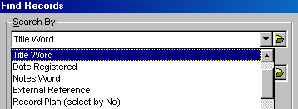
Dropdown box tool

If the desired search field is presented in the list select it and enter the search value in the field directly beneath it. However, if you would like to search using another field characteristic you will use the Kwikselect option, which is accessed using the folder icon adjacent to the dropdown.

Kwikselect Search Option
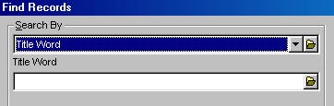
Figure 6. Kwikselect Option

When Kwikselect is chosen a list of all fields is presented from which you may select a field. Examine this hierarchical list and drill down the list by simply using the clicking the cursor on the plus sign.

For this example navigate down the list (user the + to open the list) from Locations to the field titled Owner Location. Select Ok to move the value Owner Location into the Search By field.
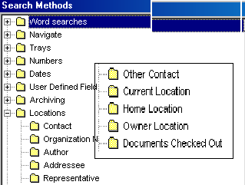
Figure 7. Hierarchical List of Search Fields

The Search value field may be populated by one of three methods. First enter the search value exactly as it is presented in the, second enter the first part of the phrase and look up and last search all citations via the Organization Tree.

- Enter an exact value in the Owner Locations Field

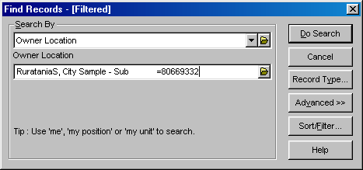
Note: As guided in this panel, if you enter me, my position, or my unit the search will be performed for that location.

- Enter partial value in the Owner Location field and use the Kwikselect to display a list of all words beginning with the select characters.

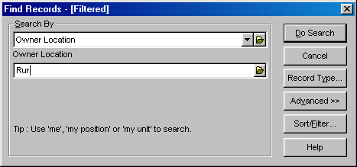
Figure 8. Searching with Partial Words

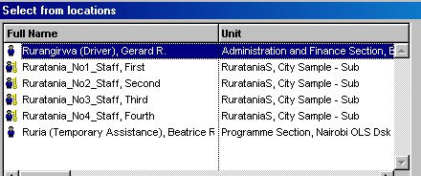
Figure 9. List of all Records starring with "Rur"

From this list of all owner locations beginning with the characters “`Rur highlight the correct entry and select Ok to populate the Owner Locations field. Now select Ok to conduct the search.

- Finally, if you have no idea which location to enter, use the Kwikselect icon and navigate down to the locations hierarchy using the + character to move down the list. Alternately use the search function.

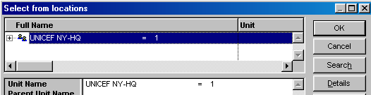
Figure 10. Top of the Locations Table

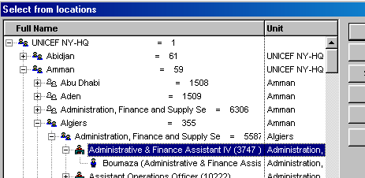
Figure 11. Typical Hierarchical Locations List after being opened using the + characters

Navigate down the hierarchical locations list and make a selection by highlighting the entry.
saved searches.

As an alternative search the Locations list with the Search function. First indicate the search is for a Staff member, Position, or Unit. Next in the Prefix field enter the last name of a Staff search, the position for a Position search, or the unit name for a Unit Search. If the search is a Staff search, you may enter initials and/or First Names. Assure the box Hierarchy View is checked and the box Deactivated Locations is checked. The search may be narrowed using the field Within Unit.

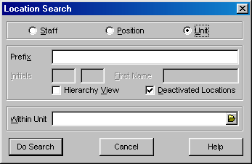
Figure 12. Locations Search Panel

1.2.3 Saved Searches

Some search criteria may be reused periodically. These search criteria can be saved using the Saved Search function. First construct a search for the word “rules.” With the search results displayed, navigate to the menu bar and select File and Save. You are presented with the search profile screen. Enter a Name and annotate the Description field as necessary. Select Ok to save the search. You may edit the query now or in the future through the Edit function. The Saved Search can be recalled and then executed anytime through the Search and Saved Search Functions or the fast path keys Ctrl-G.

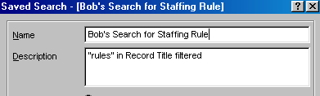
Figure 13. Partial Saved Search Screen

1.2.4 Help File

Search for more information concerning the application in the Help file. Access Help through the menu Help function or the fast path key combination Alt-H or Shift-F1.

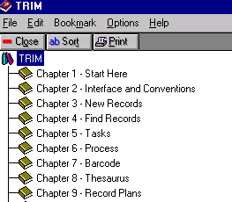
Figure 14. Help Screen

1.2.5 Record View and Record List Pane

The RAMP-TRIM screen is divided into an upper list pane and lower view pane. The search results are shown in the view pane while details of the highlighted record are shown in the view pane.

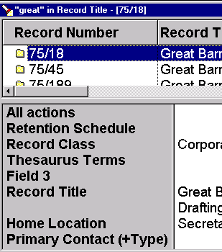

Figure 15. Record View Pane & Record List Pane

You can change the order in which fields are presented in the View Pane by placing the curser in the field, right clicking the mouse, selecting Options, moving fields to or from the Available Fields and Active Fields list, and then arranging presentation sequence by arranging the order with the up and down functions.

1.3 Overview Exercise

1.3.1 Organization Tree - Fill in Division and Section.

 | 1 | 2 | 3 | 4 | 5
Org Levels |  |  |  | Complete | Fill in your Div/Sect
Organizations | United  Nations | UNICEF | UNDP | UNICEF | UNICEF
Organization  Abbreviation | UN | CF= | DP = | CF | CF=
City | Cola | New York | Ruratania | Ruratania | New York
UN Department
Division / Office | Supply | DFAM | Programme
Section |  | Admin  Services | Health
Unit |  | Head-  quarters
Sub Unit |  | Docs &  Repro
Function

1.3.2 Display a Work Unit.

Orgs | Org  Abrev | City | [UN  Department] | Division /  Office | Section | Unit | Sub Unit
UNICEF | CF= | New York | [Operations] | DFAM | Admin  Services | Head-  quarter | Docs &  Repro
UNICEF | CF= | New York
UNICEF | CF= | New York
Information on specific Work Unit records:

- Record Series _____________________
- File Folders ______________________
- Boxes ______________________
- Shipments _____________________

1.4 Key Learning Points & Charts Used in Presentation.

1.4.1 Record Lifecycle.

(Chart)

1.4.2 RAMP-TRIM Design.

(Chart)

 |  |  |  |  |  |  |  |  |  |  | Work Unit
 |  |  |  | Record Series
 |  | List File Folders |  |  |  |  |  | List Boxes
 |  |  |  |  |  |  |  |  |  |  |  |  | Accessions
List File Items |  |  |  |  |  |  |  |  |  |  | Transfer Shipments

1.5 Self-Test.

1.5.1 Questions for RAMP-TRIM Introduction and Overview.

Q. What three ways are possible to find your work unit?
[If you do not know the full exact wording for the work unit]

A. 1)

2)

3)

Q. What is the difference between a records work unit and the series of records?

A. 1) The work unit is
2) Series are

Q. What is the difference between the various “Locations” for a record?

A. 1) The Owner Location is ____________________________________
2) The Home Location is _____________________________________
3) The Current Location is____________________________________

Q. What is the most common mistake users make in first entering the RAMP-TRIM database?

A. 1) The Caps lock is ______________________________________.

1.5.2 Questions and Answers.

Q. What three ways are possible to find your Division, Section or work unit?

A. 1) Search for Locations, via Hierarchy and drill down through the Organization Tree;
2) Search for the Division, Section or Unit by first letters of title
3) Search for a Parent unit and then use plus sign to drill down.
[If you know the exact wording of the work unit, you can go directly to it]

Q. What is the difference between the Location Work Unit and the Series of Records?

A. 1) The Work Unit is the unit that originated or owns the records or the "Who" of the records.

2) Series are the "What" of the records, what types of records, what groups of records or what cluster of records.

Q. What is the difference between the various “Locations” for a record?

A. 1) The Owner Location in RAMP-TRIM is usually the Division that the work unit creating the record reports to.
2) The Home Location is usually the work unit, which maintains the record until it is sent to a storage location.
3) The Current Location is where the record is now located. If t is borrowed it is returned to the Home location or sent temporarily to another “current” location.

Q. What is the most common mistake entering the RAMP-TRIM database?

A. 1) The Caps lock is on for the user id or password.

