
Registered for DAP as : UN-CS-RAI-USAA-DB01-2005-00167 See also footnote on UNICEF ProMS Data archival Process Summary
Registered for DAP as : UN-CS-RAI-USAA-DB01-2005-00167
Created: 21 January 2004
Last Modified: 28 April 2004
Version 1.0

About this Manual

Subject This manual is provided as a user reference for the ProMS Administration Module- Data Archival. Basic information regarding processes and operations are covered as well as detailed description of menu items. It includes general information on the benefits of archiving, who can benefit from archiving, when to archive, and how to archive.

Audience This manual is for ProMS system administrators, officers, and other staff responsible for ProMS Historical Data and ProMS Administration Module.

Format Microsoft Word 2002 (XP).

Table of Contents

Benefits of the Archival Process for a Field Office 3
General Archiving Principles 4
Scope 4
Records to be archived 4
Archival Scheduling 5
Candidates for data archival 5
Responsible Staff 5
Installation 6
Pre-requisites to Running ProMS History Data Archival 7
FO Authorisation 7
Authorisation Code 8
Other Requirements 8
ProMS History Data Archival 9
Starting the ProMS History Data Archival 9
Report Generation 9
Viewing the archival report 11
Saving the report to file 12
Data Deletion 14
Table Defragmentation 16
Performing a database backup 16
Archival Process Termination 17

Benefits of the Archival Process for a Field Office

The following benefits for the FO can be seen after running the archiving process:

Performance

The Field Office User should see a 10%-15% performance improvement in these modules under certain conditions:

- Document Action Query ( if no filters are used ).

- Payment Request Hardcopy ( displays requester, approving officer from workflow but used indexed column ).

- All View Authorised Documents.

However, in the case of FO's which are heavy users of the workflow process, they will see a more significant improvement.

- In-tray/Out-tray and document workflow log ( if they contain a lot of old entries ).

Database Size

- The archiving process will remove 2-3 years worth of old history data.

- This will not affect the size of the database unless an unload/reload will be performed which will only be done during a conversion upgrade.

- However, to force the database engine to reuse the freed up space, a defragmentation of the database tables will be performed during the archival. The result will be that the database does not increase in size for approximately 3 months [depending on the size of the database and the number of transactions which will be created].

Note: As a result there will be no improvement on database back-up time.

General Archiving Principles

The primary objective of archival is to preserve historical data while controlling the Field Office ProMS transaction database size.

The historical data that will be archived include records that document the lifespan of documents from original versions through all amendments, with complete information provided with each transaction.

The data that will be archived include non-current historical transaction documents or documents that are not expected to be updated or referenced in current transactions.

Data that will be archived will be transmitted to the NY Hub where it will stay after the data is removed from the FO database. Data will be retained in the Hub indefinitely.

Data archival will require authorisations from HQ ( Operations ), FO officers, and system administrators.

Scope

Data to be archived are the following:

Supply Requisition History Documents
Cash Requisition History Documents
Travel Authorisation History Documents
Contract Requisition History Documents
Purchase Order History Documents
Contract Obligation History Documents
Payment Request History Documents
Cash Receipt Request History Documents
JV Request History Documents
Payment Voucher History Documents
Deposit Voucher History Documents
Journal Voucher History Documents
Document Workflow Log Entries.

Records to be archived

Eligibility for archival or records is determined based on the year of the associated activity or transaction year and the current year. Records have to be associated with an activity two years prior to the last complete year to be eligible for archiving.

Archival Scheduling

Archiving will be available between the start of the second quarter and the end of the 3rd quarter of the year. This is in consideration of activities related to the yearend closure in Field Offices and HQ.

HQ (Operations and ProMS Production) will determine the schedule with input from Field Offices.

Candidates for data archival

A list of FO databases which will benefit the most from the data archival process will be maintained in HQ ( Production ).

Responsible Staff

The archival process will require the participation and authorisation from the FO Representative, Operations Officer, System Administrators, Global Help Desk, ProMS Production, Operations.

Installation

ProMS History Data archival is installed as part of the ProMS Administration Module 4.9.

No other installation or setup procedure is required.

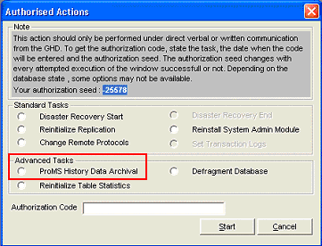
Figure 1

Access to ProMS History Data Archival task is controlled by HQ. If access has not been granted, the option is grayed-out and will not be available for selection.

Pre-requisites to Running ProMS History Data Archival

Before ProMS history data archival can be performed, an authorisation from an officer in the Field Office and an authorisation code fromGlobal Help Desk must be secured.

FO Authorisation

FO authorisation for performing the ProMS history data archival is registered in ProMS using the Archival Authorisation screen.

To open the Archival Authorisation Window, click on Modules-Archive.

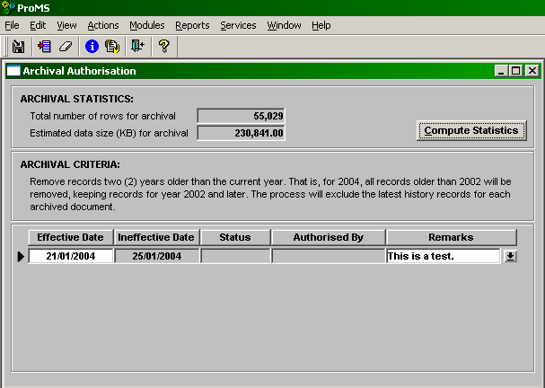
Figure 2

The Effective date range should include the date when the data archival is expected to take place.

If no authorised entry is found during the archival process, the following message will be displayed:

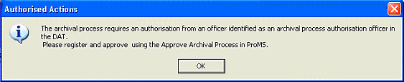

An entry must be registered and authorised by an authorising officer registered in the Document Authorisation table.

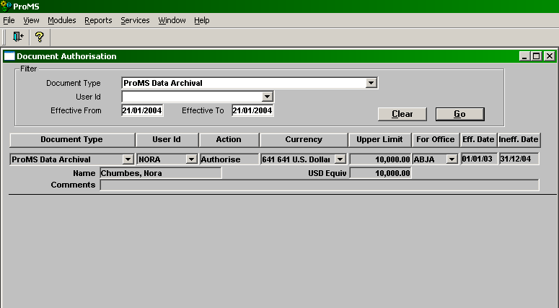
Figure 3

Authorisation Code

ProMS history data archival is an advanced activity which will require special authorisation code from Global Help Desk. Please refer to the ProMS Administration Module User Manual ( section How to get an authorization code ) for instructions on getting authorisation codes.

See section After getting the authorization code in the ProMS Administration Module User Manual for instructions on starting tasks.

Other Requirements

ProMS history data archival requires the following:

1. That there are no other connections to the database.

If other connections are found, the following message will be displayed:

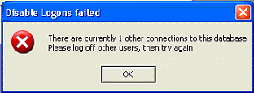

2. A database backup has been performed on the same day.

NOTE: Perform the FULL database backup before executing the data archival.

If no record of a backup exists on the same day, the following message will be displayed:

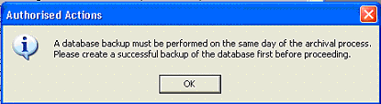

3. ProMS Administration Scheduler is cleared of scheduled activities prior to starting the archival process.

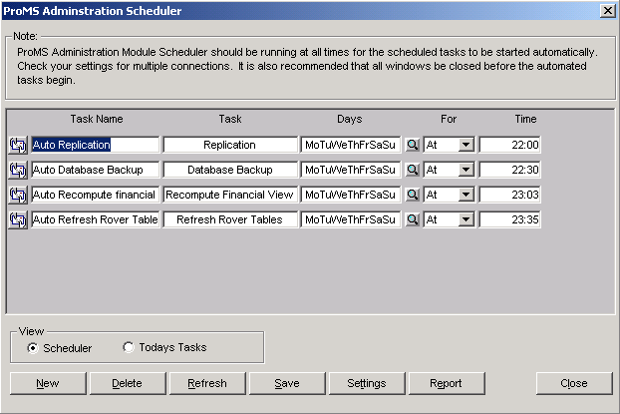

ProMS History Data Archival

Starting the ProMS History Data Archival

To start the data archival, the system administrator should do the following:

1. Log into the system administration module

2. Execute the data archival advance task ( see the pre-requisites above and the section After getting the authorization code in the ProMS Administration Module User Manual for instructions on starting tasks.

Report Generation

The archival process starts by generating a report of data that will be archived. The following window will be displayed to show the status of the report generation.

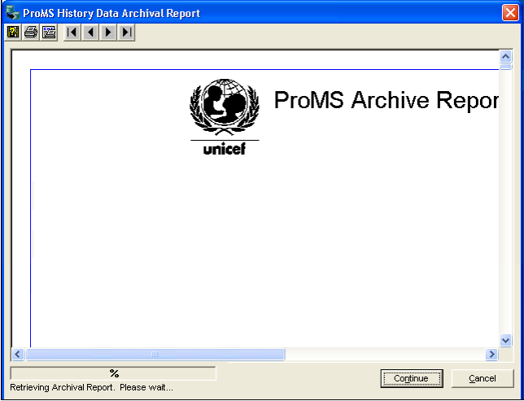

When done, the report will be displayed.

Viewing the archival report

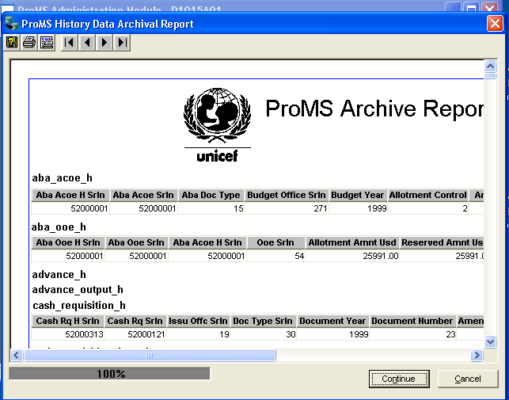

It may take several minutes to display the report depending on the amount of data available.

Saving the report to file

The archival process requires that the data be saved first in a PDF Format and then in Excel Format.

The PDF file is an official record of records that will be removed by the archival process.

Note!!! Please make sure the default printer is set to 'Sybase Datawindow PS'. You will not be able to save to PDF if the default printer is not set to 'Sybase Datawindow PS.'

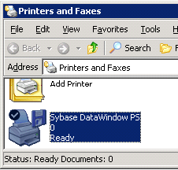

The Excel file will allow users to perform customised queries for local use.

Click on the Continue button to proceed.

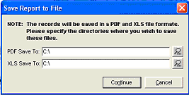

The status bar will be updated to show the progress of saving the report to PDF file.

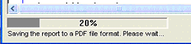

When done, the report will automatically save the report in Excel Format.

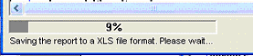

When done, the following message will be displayed.

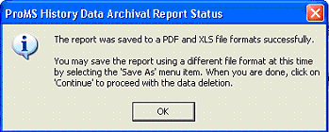

Click OK to continue.

Data Deletion

The data included in the report will now be deleted.

The following screen will be displayed to display information on the data to be deleted.
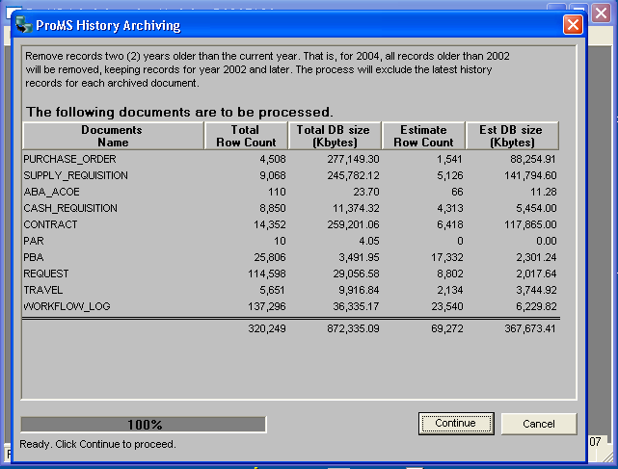

Click on Continue to proceed with the data deletion.

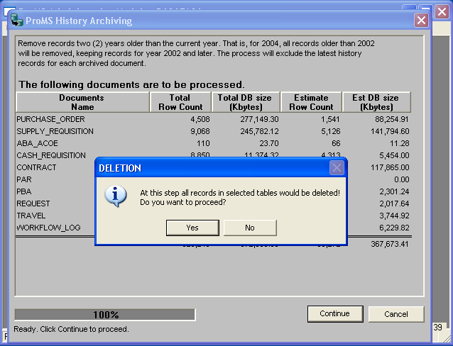

Again, click on Continue to proceed with the data deletion.

The status bar will be updated to indicate the progress of the data deletion.

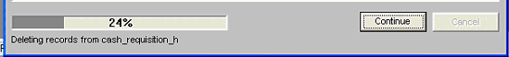

When done, the following message will be displayed.

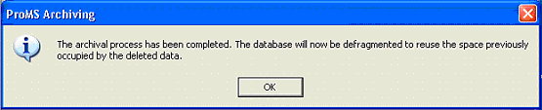

Click on OK to continue.

At this time, all deletes are saved to the database.

Table Defragmentation

The process now continues with the defragmentation of the database tables affected by the archival process. This process may take several minutes to complete.

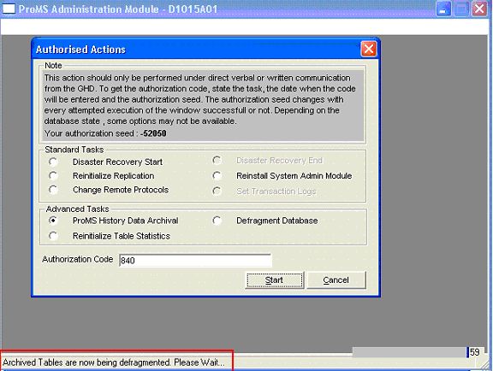

See Defragment Database section in the ProMS Administration Module User Manual for more information on this activity.

When done, the following message will be displayed.
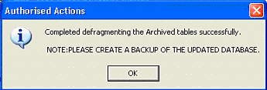

Performing a database backup

After the archival process is completed, perform a database backup.

The ProMS Historical Data Archival is now complete!

Archival Process Termination

When the archival process is terminated due to user action or error, no changes will be applied to the database.

To restart the archival process, the entire process must be repeated. See above for the pre-requisites for archival.

Summary of ProMS Data archival Process: 1. FO initials request to HQ for data archival. 2. FO runs data archival locally. 3. The result of data archival is saved in PDF formatted files. 4. The PDF files are saved in a CD and a copy of the CD is sent to HQ.

